**Additional Notes on Safety Resources**

**Overloaded Sockets Game**

**KS2**

Activity summary:

Discuss amps and watts and what they mean. Discus how to identify if it safe to plug in/use an electrical item based on this.

Cut out the objects and plug them into the sockets, adding up how much power they are using as you do so. Be careful not to overload the sockets. Could be played where you add up as you go, or could reveal the wattage at the end to see who has won/whose is safe.

Learning objectives:

To understand how power works in relation to electricity, what can happen if you overload a socket and why it could be dangerous.

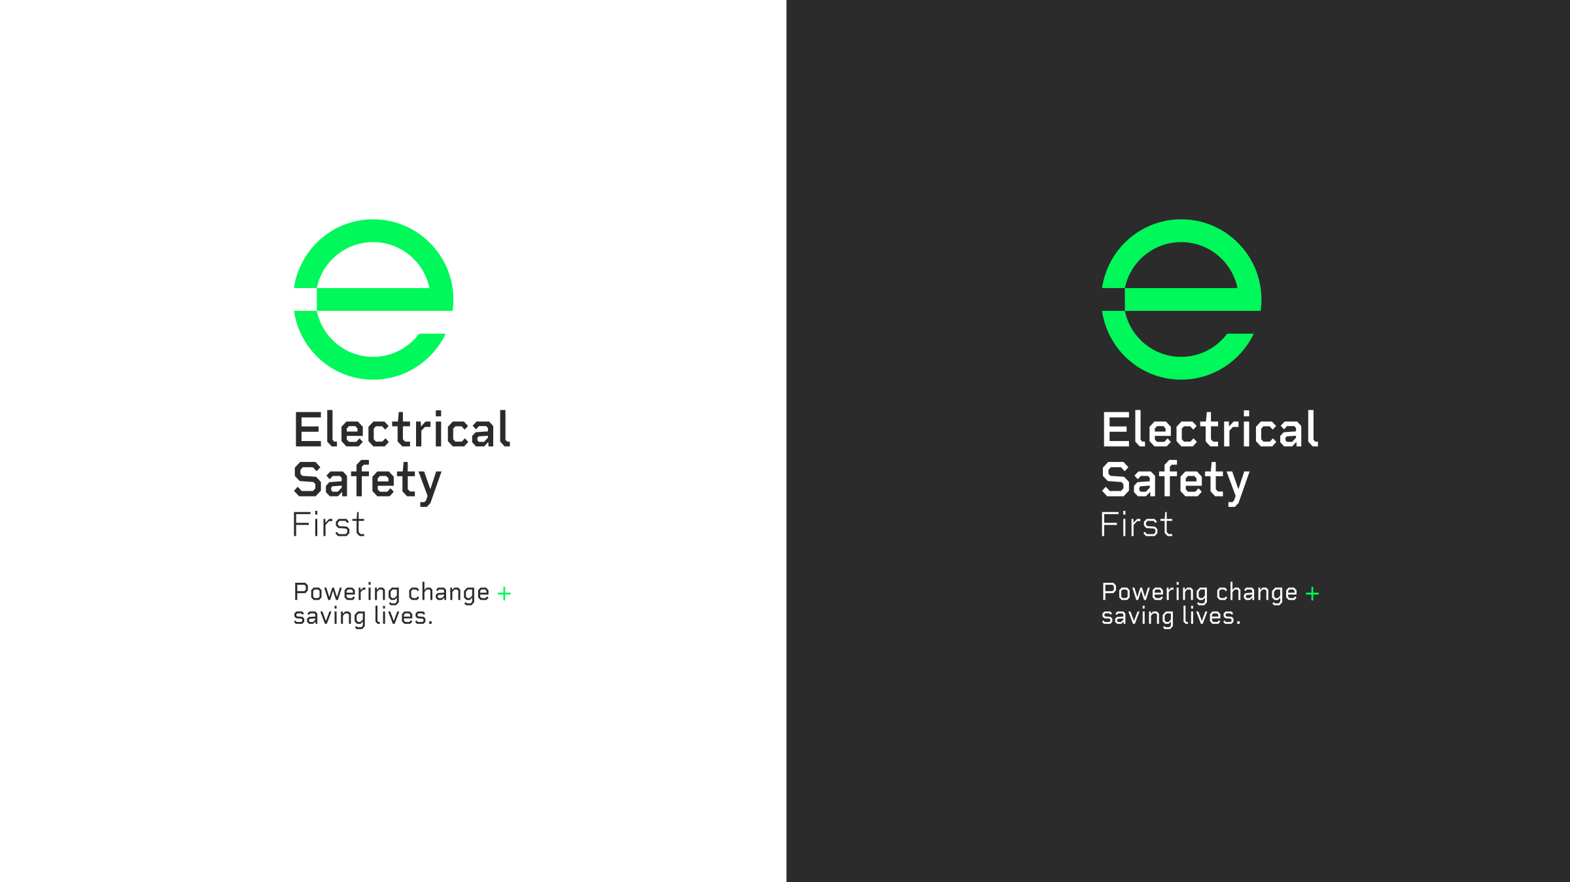Additional Resources:

<https://science.howstuffworks.com/environmental/energy/question501.htm>

