**ELECTRICAL DIARY LESSON PLAN**

**Introduction (10 mins)**

Expla

in

the

importance

of

electrical

safety

in

homes

Show exam

ples of safe practices (e.g., using surge

protectors)

**Main Activity (30 mins)**

Provide a template for the electricity diary

Examples of entries (e.g., “Checked plug sockets in

the

living

room”,

“Noticed

a

frayed

wire

on

the

kettle”)

Brainstorm common hazards: overloaded sockets,

damaged cables, water near electrical items

**Gr**

**oup Discussion (15 mins)**

Share diary entries and discuss any hazards found

Discuss

solutions

to

hazards

(

e.g.,

Getting old

wires replaced – not to touch them ourselves!)

**Con**

**clusion (5 mins)**

Highlight the role of regular checks in preventing

hazards

Encourage ongoing use of the diary



any electrical hazards to spot? How is your home electrically safe?



MY

ELECTRICTY

DIARY

Take a walk around

the different rooms in your home. Are there



LIVING ROOM

Have a look around your living room. How is electricity being used?

Are there any hazards to be aware of e.g.

overloaded sockets?

What are you doing in your home to make sure electricity is used

safely?



Have a look around your kitchen. How is electricity being used?

Are there any hazards to be aware of e.g.

mains objects close to

the water, trailing cables near the cooker? What are you doing in

your home to make sure electricity is used safely?

KITCHEN

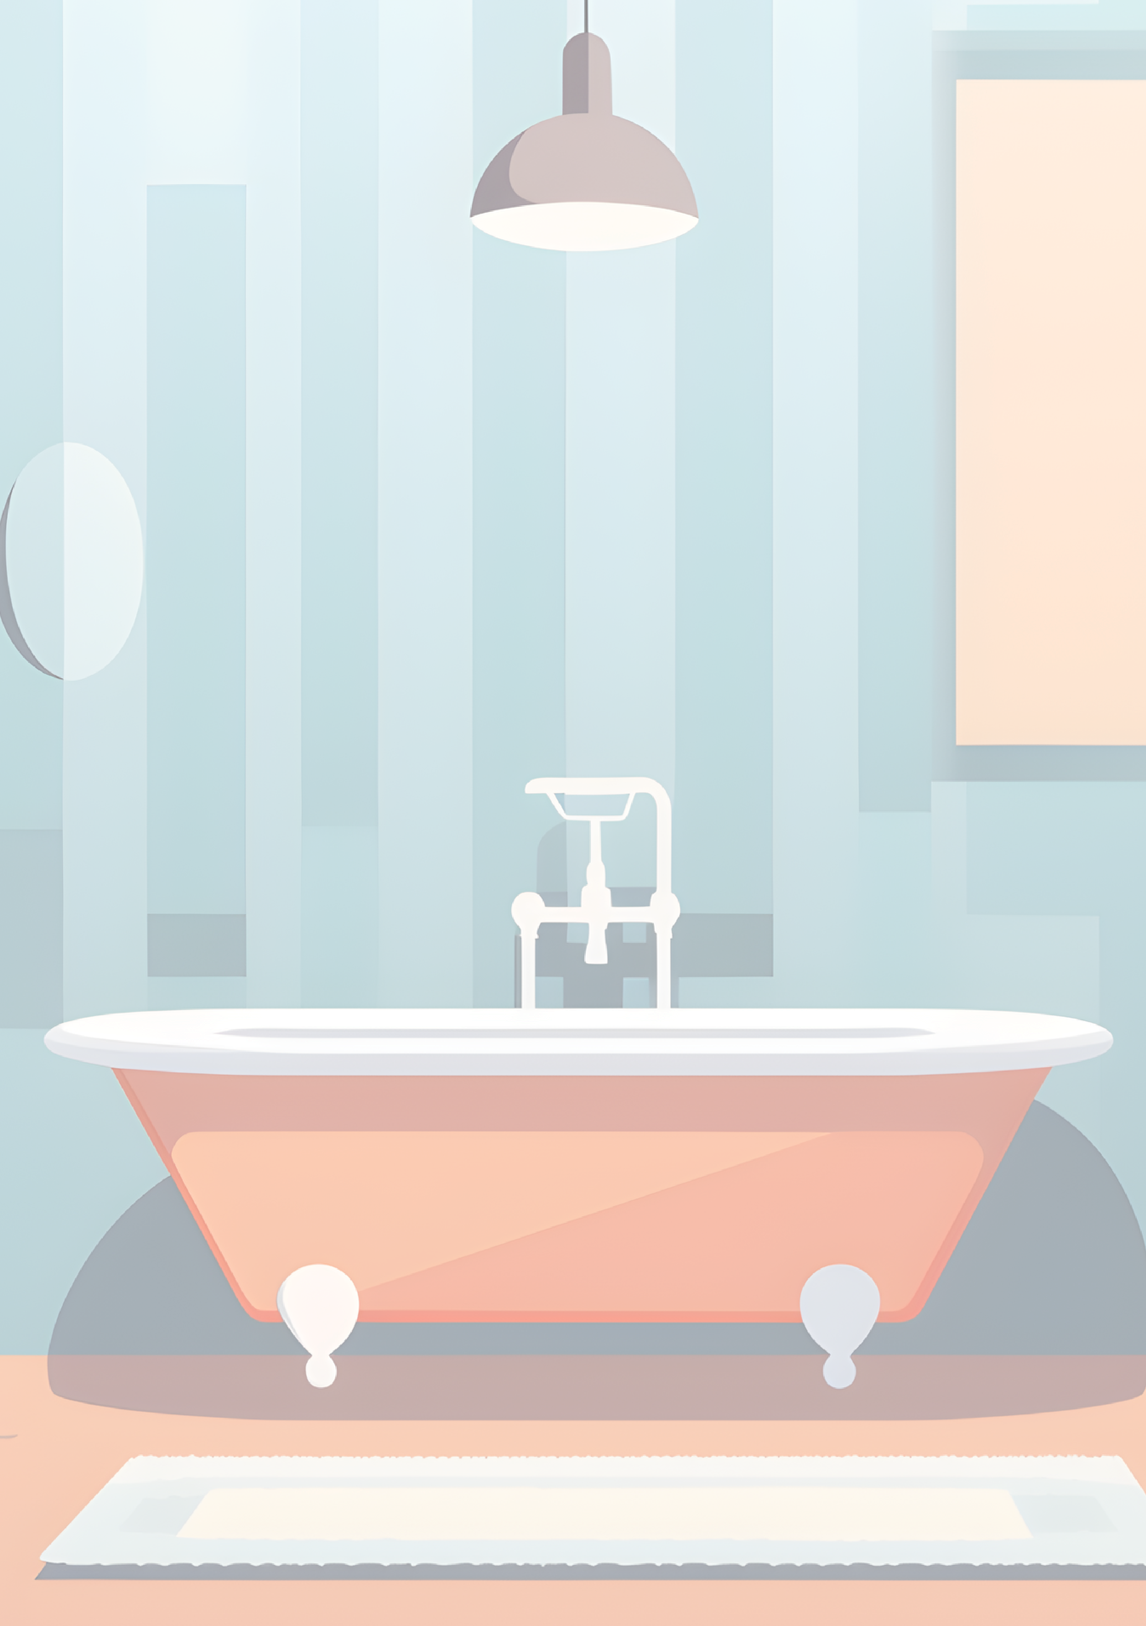

Have a look around your bathroom How is electricity being used?

Are there any hazards to be aware of e.g.

mains objects close to

the water, trailing cables across the floor? What are you doing in

your home to make sure electricity is used safely?

BATHROOM

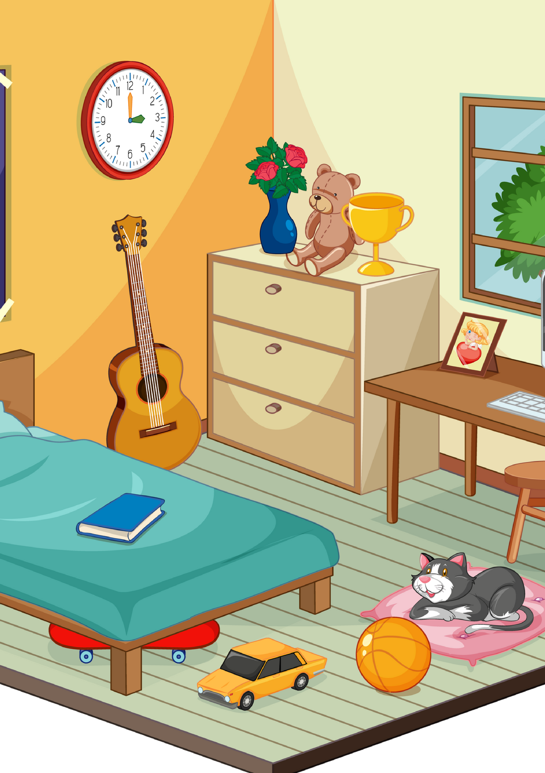

Have a look around your bedroom. How is electricity being used?

Are there any hazards to be aware of e.g.

drinks near electrical

objects?

What are you doing in your home to make sure electricity

is used safely?

BEDROOM

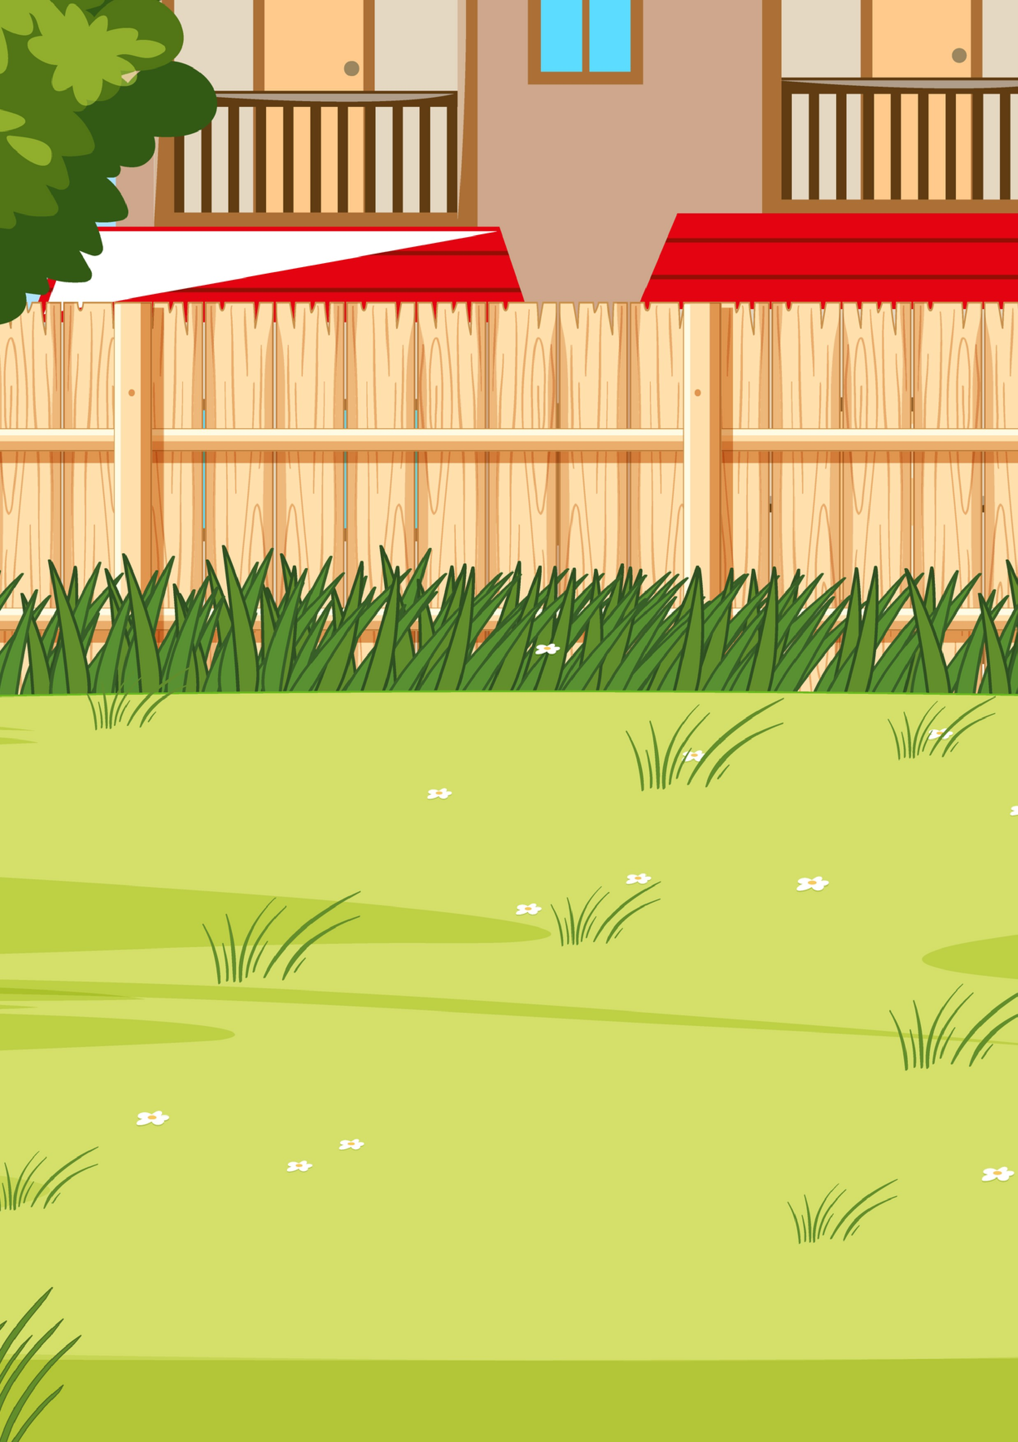

Have a look around your garden. How is electricity being used?

Are there any hazards to be aware of e.g. electric garden tools

near water, cables trailing across paths?

What are you doing in

your home to make sure electricity is used safely?

GARDEN