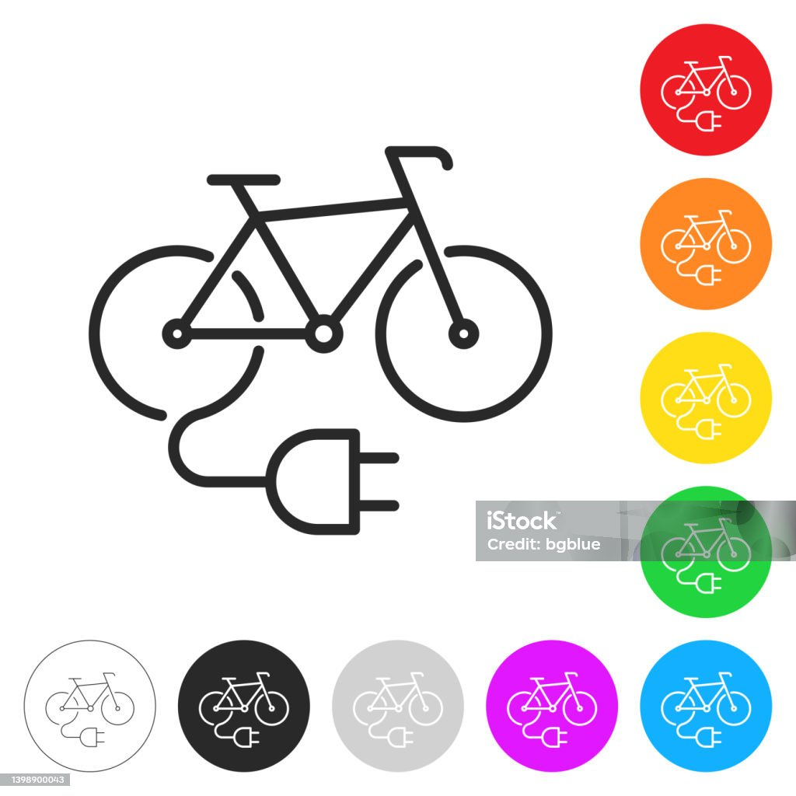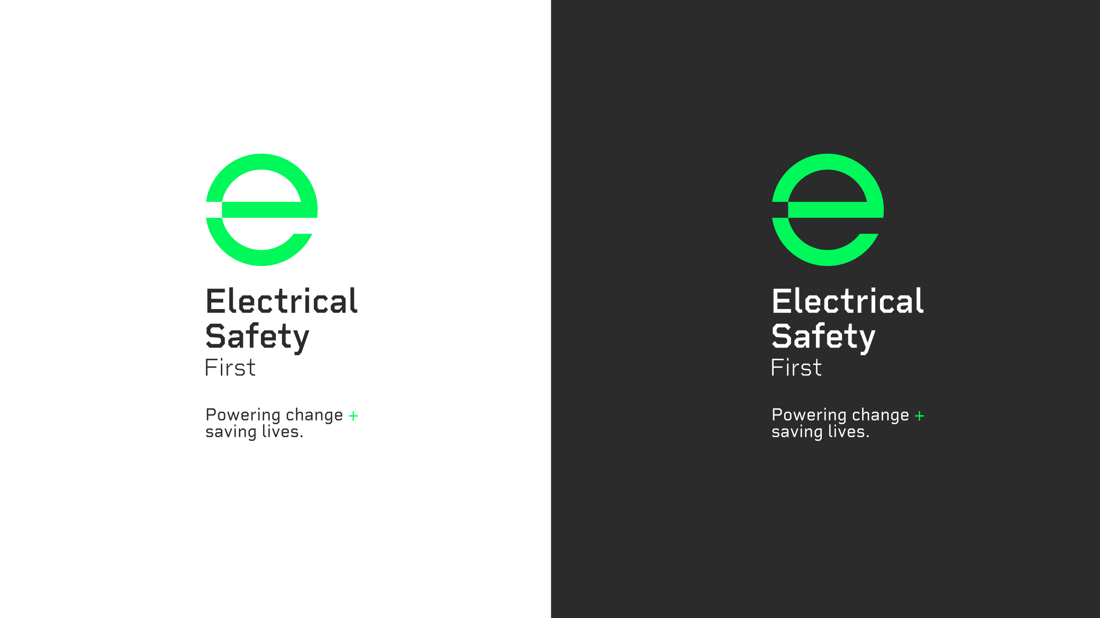

You are a safety superstar!

Electrical Safety: Electric Bikes

You check your battery for damage. Well done! Roll the dice again.

You overcharge your battery! This can be dangerous! Move back one space.





You leave your electric bike blocking the escape route. This is unsafe! Miss a go.

You cover your e bike charger when it is charging. This is unsafe! Follow the arrow to move back.



You put a smoke alarm in the area where you charge your e bike. Super safety! Roll the dice again!

You leave your e bike charging at home and go out to the shop. This is unsafe! Go back 4 spaces.

You unplug your e bike charger when you have finished charging it. Fantastic! Follow the arrow to move forwards.







You buy a replacement charger from the original, reputable manufacturer. This is smart! Follow the arrow to move on.

You continue to use a damaged battery. This can be dangerous! Go back three spaces.



You buy a safe e bike from a trusted retailer and manufacturer. Great! Move forward 3 spaces.

You spot a warning sign (over heating) that your e bike may be a fire hazard. Well done! Move forward two spaces.

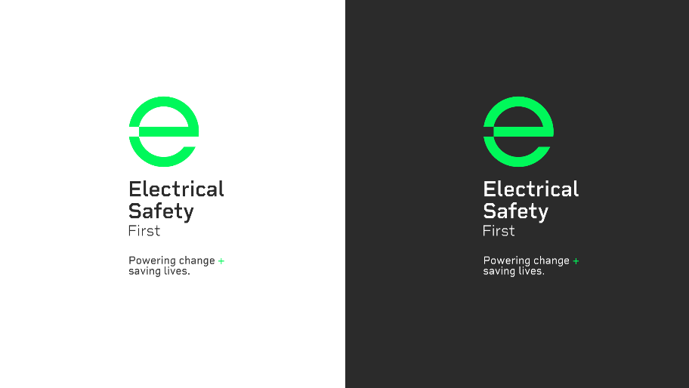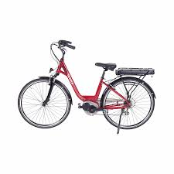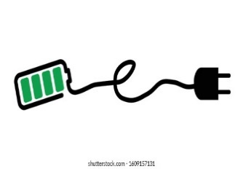









|  |  |  |
| --- | --- | --- |
| LOGO_ASSETS690+ Electric Bike Charging Stock Illustrations, Royalty-Free Vector  Graphics & Clip Art - iStock    You buy a replacement charger for your e bike on social media. This is unsafe.  Sad face outline with solid fillMiss a go. | 690+ Electric Bike Charging Stock Illustrations, Royalty-Free Vector  Graphics & Clip Art - iStock  Dice Red PNG Clip Art - Best WEB Clipart You notice that there are no instructions or warranty included with your e bike. You suspect it may be faulty and return it. This is smart! Roll the dice again! | 690+ Electric Bike Charging Stock Illustrations, Royalty-Free Vector  Graphics & Clip Art - iStock  Sad face outline with solid fillYou notice a burning smell coming from your battery but ignore it. This is unsafe. Miss a go. |
| 690+ Electric Bike Charging Stock Illustrations, Royalty-Free Vector  Graphics & Clip Art - iStock    Dice Red PNG Clip Art - Best WEB Clipart You hear a hissing, crackling sound coming from your battery! You stop using it and report it. Well done! Roll the dice again! | 690+ Electric Bike Charging Stock Illustrations, Royalty-Free Vector  Graphics & Clip Art - iStock  Sad face outline with solid fill You try to modify and tamper with your e bike battery! This can be dangerous!  Miss a go. | 690+ Electric Bike Charging Stock Illustrations, Royalty-Free Vector  Graphics & Clip Art - iStock    Dice Red PNG Clip Art - Best WEB Clipart You want to buy a new electric bike. You read lots of product reviews and research your new bike carefully. This is smart! Roll the dice again. |
| 690+ Electric Bike Charging Stock Illustrations, Royalty-Free Vector  Graphics & Clip Art - iStock  A red and black logo  Description automatically generatedDice Red PNG Clip Art - Best WEB Clipart You identify that your battery is bulging and swollen and know that this is a common sign of it failing. You stop using it and report it immediately. Well done! Roll the dice again!  LOGO_ASSETS | 690+ Electric Bike Charging Stock Illustrations, Royalty-Free Vector  Graphics & Clip Art - iStock  Dice Red PNG Clip Art - Best WEB Clipart You identify that your battery is hot to the touch. You think it is a fire hazard. You stop using it and report it. This is smart! Roll the dice again! | 690+ Electric Bike Charging Stock Illustrations, Royalty-Free Vector  Graphics & Clip Art - iStock  Sad face outline with solid fill You leave your electric bike charging overnight and go to bed. This is dangerous! Miss a go. |



Electrical Safety: Electric Bikes

Instructions

For 2-4 players.

You will need:

counters

Choose a counter each and place it on the start position.

Take turns to roll the dice and move along the board.

If you land on a take a chance card.

The first player to reach the finish is the winner!

Enjoy playing the game and learning all about e bike electrical safety!



dice



This activity was produced by Schoolzone on behalf of Electrical Safety First, the UK's leading charity working to keep families safe when using electricity at home.

Visit our *Switched On Kids website*for more.