**Additional Notes on Safety Resources**

**E-Bikes Board Game**

**KS2**

Activity summary:

Through rolling the dice and moving around the board, students will learn about safe and unsafe practice around e-bikes. Good safety practice advances you around the bad, bad practice sends you back.

Learning objectives:

From the PowerPoint they will learn about how to safely buy an e-bike, what to look out for when purchasing, how to safely charge the battery, what not to do with the battery and what hazards to look out for with their e-bike.

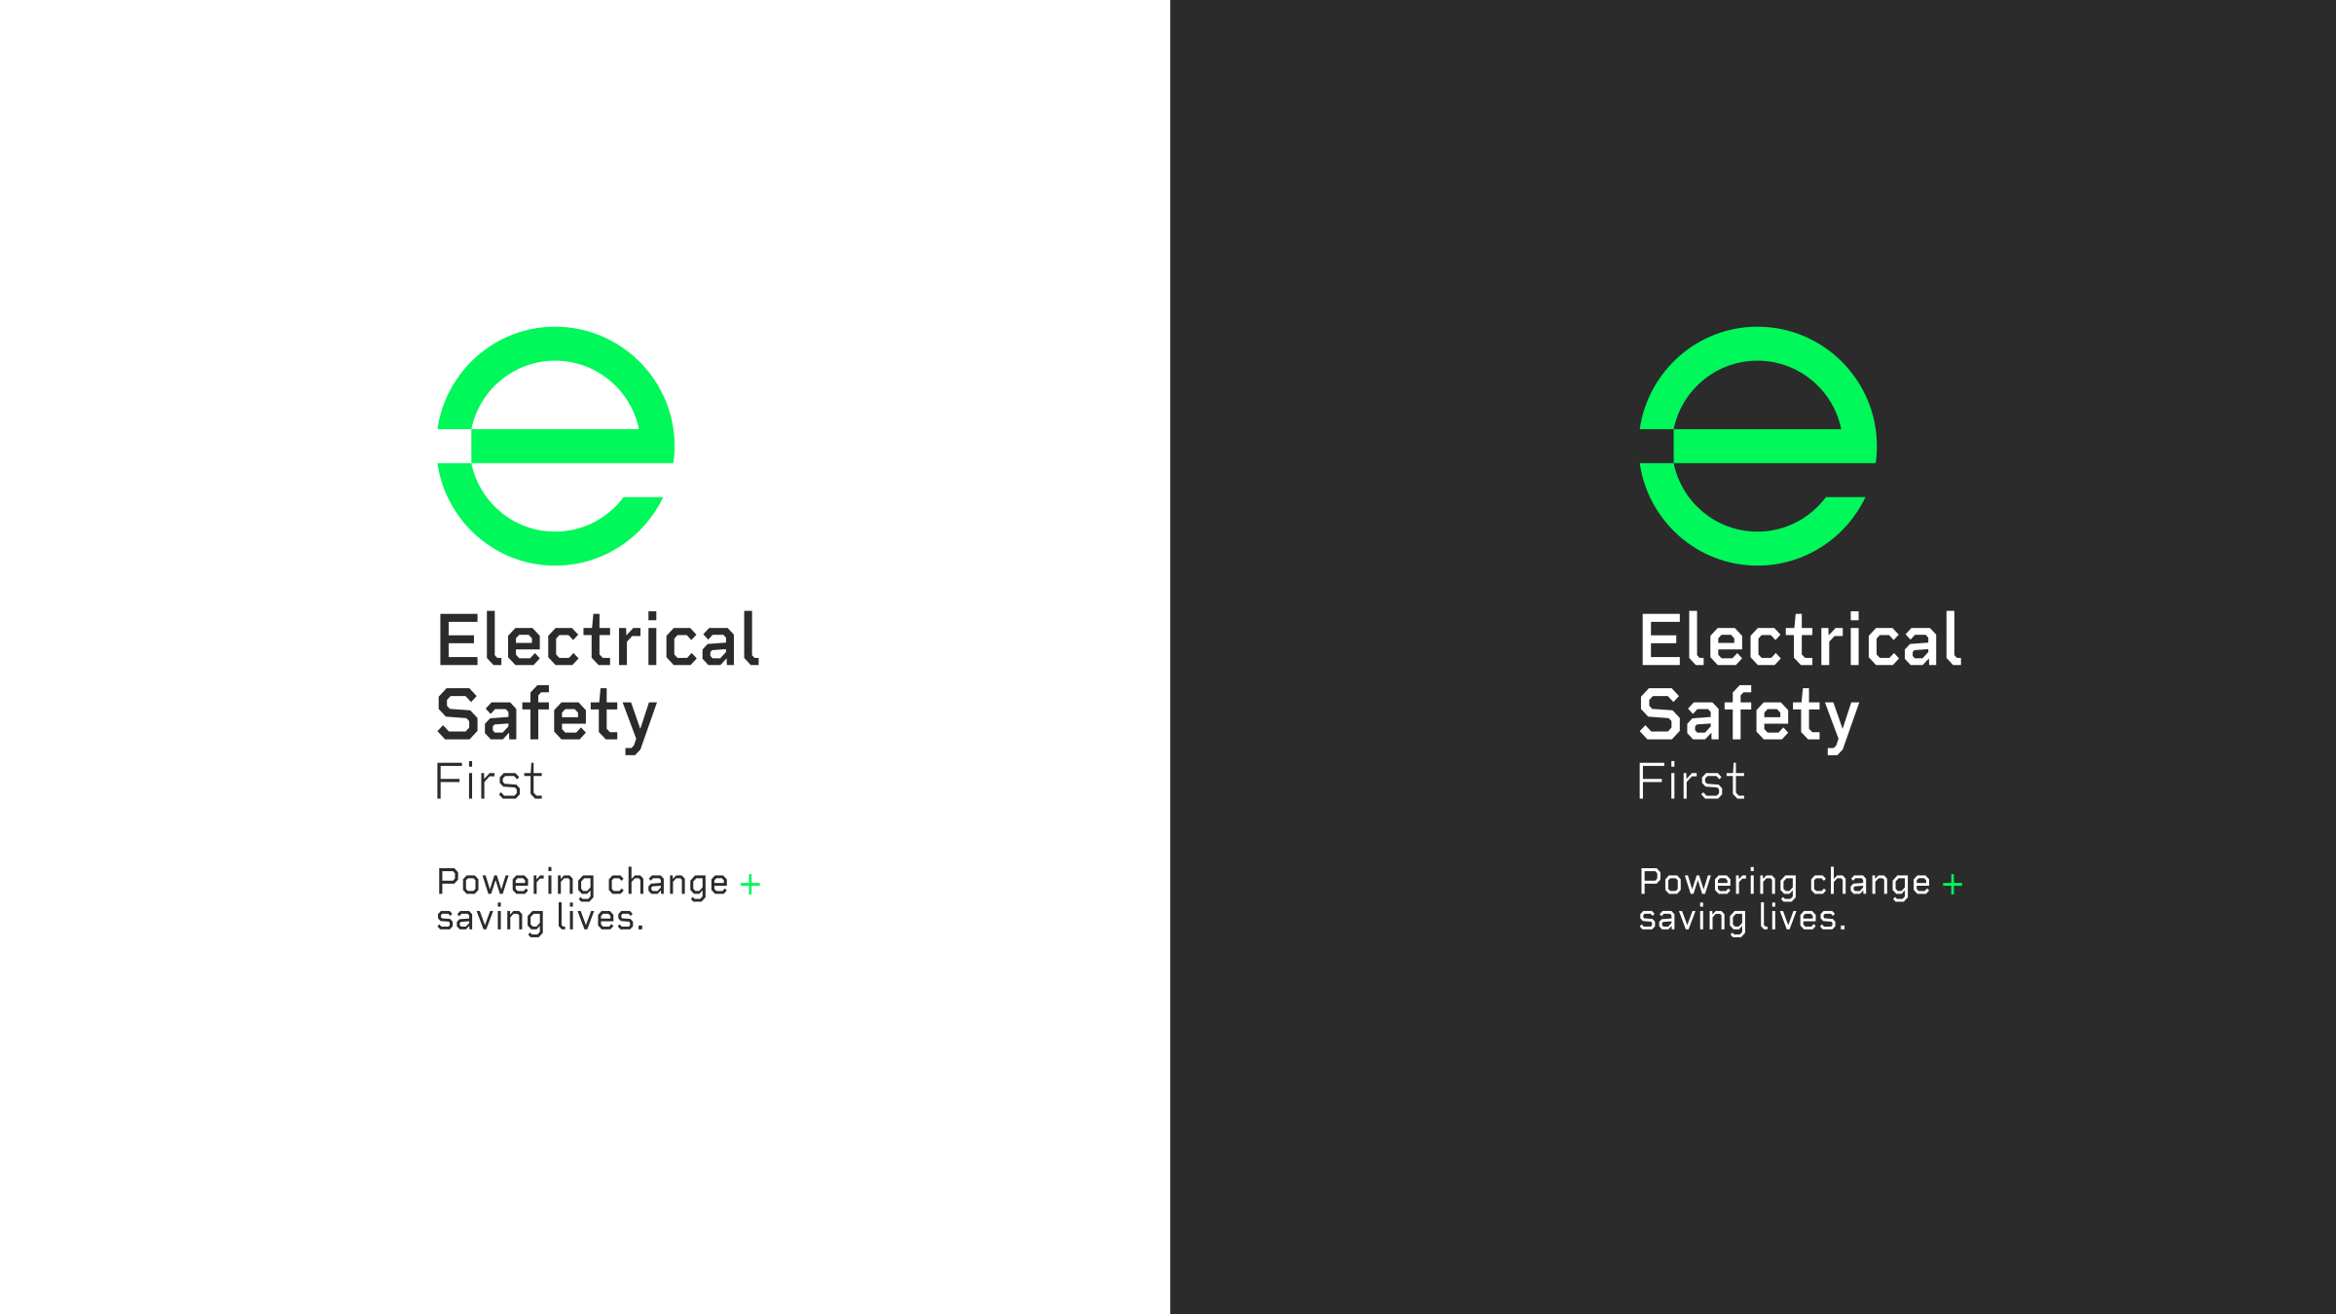Additional Resources:

E-Bikes PowerPoint

