**Battery Safety Squad (Age 9 – 11/ Upper Keystage 2)**

**Learning Objectives:**

Tounderstand the risks associated with charging lithium batteries at home, particularly the dangers linked to e-bike charging and the potential for domestic fires.

To explore safety measures that can reduce fire risks when charging devices at home.

To develop practical safety awareness

**Curriculum Links:**

**England**

**Science:** Understanding electricity, chemical reactions in batteries, and fire safety aligns with the National Curriculum focus on electricity and safety.

**PSHE:** Personal safety, responsible use of technology, and understanding fire safety.

Geography: Considering the environmental impact of lithium batteries links to human and physical geography.

**Maths:** Collecting, analysing, and presenting data on battery safety risks.

**English**: Report writing, persuasive arguments, and presentations enhance speaking and listening skills.

**Art/Design Technology**: Creating safety posters and designing safety plans link to creative and technical skills development.

**Wales**

**Science and Technology:** Understanding physical processes (electricity), safety, and responsible use of technology.

**Health and Well-being:** Personal safety and managing risks.

**Humanities:** Understanding environmental impacts links to geographical knowledge.

**Mathematics and Numeracy:** Data handling and analysis.

**Language, Literacy, and Communication:** Developing communication skills through presentations and persuasive writing.

**Expressive Arts:** Creating informative posters and visual content.

**Scotland**

**Sciences:** Learning about electrical circuits, energy, and sustainability (SOC 2-04a, SCN 2-10a).

**Health and Wellbeing:** Understanding safety and risk management (HWB 2-17a).

**Social Studies:** Exploring the impact of human activity on the environment (SOC 2-08a).

**Mathematics:** Developing data handling skills (MNU 2-20b).

**Literacy:** Building skills in writing and presenting information (LIT 2-20a).

**Expressive Arts:** Using creativity to design safety posters and plans (EXA 2-06a).

**Northern Ireland**

**The World Around Us: Science** (understanding electricity and chemical reactions) and geography (impact of technology on the environment).

**Personal Development and Mutual Understanding:** Personal safety, home safety, and responsible technology use.

**Mathematics and Numeracy:** Data collection, analysis, and representation.

**Language and Literacy:** Report writing, persuasive arguments, and presentations.

**The Arts:** Creating safety posters and design tasks enhance artistic skills.

**Activity Summary (learning over the course of 3 activities):**

Children will become a collaborative "Battery Safety Squad" tasked with investigating the dangers of charging lithium batteries at home, with a particular focus on e-bikes. Through practical activities, group discussions and creative tasks, children will learn about fire risks and the steps they can take to safeguard their homes. The activity will culminate the development of safety plans for their own homes and information that can be shared with the rest of the school community.

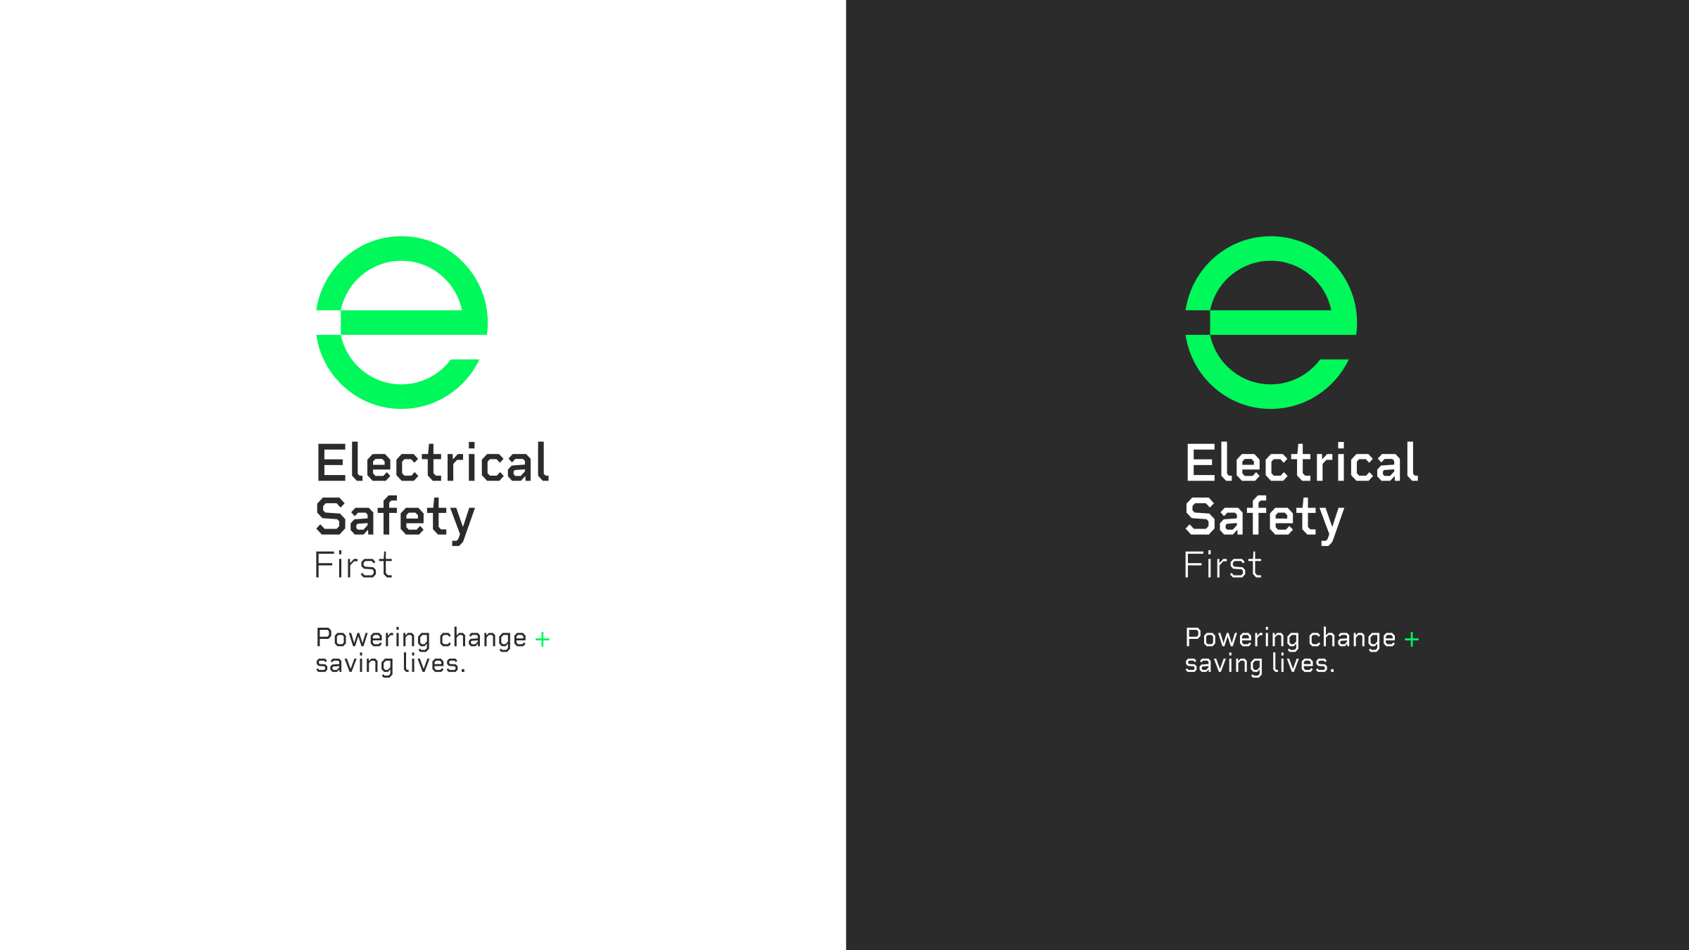

**Activity 1 (Battery risks and safety)**

**Introduction and Context (15 minutes)**

Introduce a scenario where the "Battery Safety Squad" are called to investigate a series of incidents involving e-bikes and other lithium battery-powered devices causing fires in homes. The class is tasked with figuring out why these fires happen and how they can prevent them.

**Start a class discussion with questions like:**

What devices in your home use lithium batteries?

Do you or anyone you know have an e-bike or similar device?

What do you think happens if these batteries are not charged properly?

Explain that they will learn about the science behind lithium batteries, why they can be dangerous, especially when charging, and what safety measures can prevent accidents.

**Hands-On Investigation (45 minutes)**

Interactive Demonstration – "Inside a Lithium Battery":

Watch [https://youtu.be/4Nsgzb9gnHs?si=BOzgy4D-e_AQo-qV](https://eur02.safelinks.protection.outlook.com/?url=https%3A%2F%2Fyoutu.be%2F4Nsgzb9gnHs%3Fsi%3DBOzgy4D-e_AQo-qV&data=05%7C02%7CBowenM43%40monmouthshireschools.wales%7Cb0fa55d9d9c349fc872b08dcc384432f%7C4f3f0e52b734416494091b601d147993%7C0%7C0%7C638600220070567522%7CUnknown%7CTWFpbGZsb3d8eyJWIjoiMC4wLjAwMDAiLCJQIjoiV2luMzIiLCJBTiI6Ik1haWwiLCJXVCI6Mn0%3D%7C0%7C%7C%7C&sdata=Kd3pWeLlYyTjwCC0thB8vcIml12nNk71VZ3FXO3p2sQ%3D&reserved=0) from 24.58 to 30.17

Then discuss the basic components of a lithium battery (replaying portions of the video, as necessary) and how they store and release energy.

Explain how overheating, overcharging, or damage can lead to fires building on the information from the previous video and using [https://youtu.be/yaREuhN12FI?si=bT-kxn0NpEBvv2YU](https://eur02.safelinks.protection.outlook.com/?url=https%3A%2F%2Fyoutu.be%2FyaREuhN12FI%3Fsi%3DbT-kxn0NpEBvv2YU&data=05%7C02%7CBowenM43%40monmouthshireschools.wales%7Cb0fa55d9d9c349fc872b08dcc384432f%7C4f3f0e52b734416494091b601d147993%7C0%7C0%7C638600220070576794%7CUnknown%7CTWFpbGZsb3d8eyJWIjoiMC4wLjAwMDAiLCJQIjoiV2luMzIiLCJBTiI6Ik1haWwiLCJXVCI6Mn0%3D%7C0%7C%7C%7C&sdata=lhOmw5c3GVGT50qjoGLOMM3itiQCD5XhIIk%2FhM%2FGlcM%3D&reserved=0)

**Safe Charging Habits Brainstorm**

In small groups, children brainstorm what they think are safe practices for charging lithium batteries (e.g. using the correct charger, avoiding overcharging, not charging near flammable materials). They write these ideas on sticky notes and place them on a "Safety Wall" for the class to review and discuss, following the next part of the activity:

Watch [https://www.youtube.com/watch?v=5lJcNSmZ020](https://eur02.safelinks.protection.outlook.com/?url=https%3A%2F%2Fwww.youtube.com%2Fwatch%3Fv%3D5lJcNSmZ020&data=05%7C02%7CBowenM43%40monmouthshireschools.wales%7Cb0fa55d9d9c349fc872b08dcc384432f%7C4f3f0e52b734416494091b601d147993%7C0%7C0%7C638600220070583047%7CUnknown%7CTWFpbGZsb3d8eyJWIjoiMC4wLjAwMDAiLCJQIjoiV2luMzIiLCJBTiI6Ik1haWwiLCJXVCI6Mn0%3D%7C0%7C%7C%7C&sdata=WwhVHVefSNWBCE%2BMTNJ%2FYloSe9gM8%2BeelUJ2x3u4tfs%3D&reserved=0)  and [https://youtu.be/oPQQMJk8bP8?si=lWyvNenuFBit4C-r](https://eur02.safelinks.protection.outlook.com/?url=https%3A%2F%2Fyoutu.be%2FoPQQMJk8bP8%3Fsi%3DlWyvNenuFBit4C-r&data=05%7C02%7CBowenM43%40monmouthshireschools.wales%7Cb0fa55d9d9c349fc872b08dcc384432f%7C4f3f0e52b734416494091b601d147993%7C0%7C0%7C638600220070588739%7CUnknown%7CTWFpbGZsb3d8eyJWIjoiMC4wLjAwMDAiLCJQIjoiV2luMzIiLCJBTiI6Ik1haWwiLCJXVCI6Mn0%3D%7C0%7C%7C%7C&sdata=Baag84wgxThS%2BLnXbEdkNcZmNGq7WfNyY7T41Jl2d7I%3D&reserved=0) focusing on official advice about e-bike safety/charging. As a class, evaluate how well our brainstormed ideas matched the official guidance.

**Battery Safety Squad Investigation:**

Provide the children will a selection of different case studies of real-life e-bike fires. Some could include:

[https://www.essex-fire.gov.uk/incidents/man-escapes-injury-after-e-bike-catches-fire-2024-06-21-17-03](https://eur02.safelinks.protection.outlook.com/?url=https%3A%2F%2Fwww.essex-fire.gov.uk%2Fincidents%2Fman-escapes-injury-after-e-bike-catches-fire-2024-06-21-17-03&data=05%7C02%7CBowenM43%40monmouthshireschools.wales%7Cb0fa55d9d9c349fc872b08dcc384432f%7C4f3f0e52b734416494091b601d147993%7C0%7C0%7C638600220070594219%7CUnknown%7CTWFpbGZsb3d8eyJWIjoiMC4wLjAwMDAiLCJQIjoiV2luMzIiLCJBTiI6Ik1haWwiLCJXVCI6Mn0%3D%7C0%7C%7C%7C&sdata=a3aGYlZkDdRajBrmfnQhkYu6aMhsEUdiqW91LoRnhE4%3D&reserved=0)

[https://www.youtube.com/watch?v=akqhkj8owxQ](https://eur02.safelinks.protection.outlook.com/?url=https%3A%2F%2Fwww.youtube.com%2Fwatch%3Fv%3Dakqhkj8owxQ&data=05%7C02%7CBowenM43%40monmouthshireschools.wales%7Cb0fa55d9d9c349fc872b08dcc384432f%7C4f3f0e52b734416494091b601d147993%7C0%7C0%7C638600220070601012%7CUnknown%7CTWFpbGZsb3d8eyJWIjoiMC4wLjAwMDAiLCJQIjoiV2luMzIiLCJBTiI6Ik1haWwiLCJXVCI6Mn0%3D%7C0%7C%7C%7C&sdata=uWAnnAtSPhk2sQNwvORaCq1NQczNSyi2extzcgatrT4%3D&reserved=0)

[https://www.essex-fire.gov.uk/incidents/pets-rescued-fire-caused-e-bike-charger-2023-10-15-11-06](https://eur02.safelinks.protection.outlook.com/?url=https%3A%2F%2Fwww.essex-fire.gov.uk%2Fincidents%2Fpets-rescued-fire-caused-e-bike-charger-2023-10-15-11-06&data=05%7C02%7CBowenM43%40monmouthshireschools.wales%7Cb0fa55d9d9c349fc872b08dcc384432f%7C4f3f0e52b734416494091b601d147993%7C0%7C0%7C638600220070608001%7CUnknown%7CTWFpbGZsb3d8eyJWIjoiMC4wLjAwMDAiLCJQIjoiV2luMzIiLCJBTiI6Ik1haWwiLCJXVCI6Mn0%3D%7C0%7C%7C%7C&sdata=idz4Hxplq1QtJLtmW0%2FyH92AjDDTA0%2F7D45xqI%2FnCjE%3D&reserved=0)

[https://www.lbhf.gov.uk/news/2024/07/e-bike-battery-starts-major-blaze-hammersmith-block](https://eur02.safelinks.protection.outlook.com/?url=https%3A%2F%2Fwww.lbhf.gov.uk%2Fnews%2F2024%2F07%2Fe-bike-battery-starts-major-blaze-hammersmith-block&data=05%7C02%7CBowenM43%40monmouthshireschools.wales%7Cb0fa55d9d9c349fc872b08dcc384432f%7C4f3f0e52b734416494091b601d147993%7C0%7C0%7C638600220070614915%7CUnknown%7CTWFpbGZsb3d8eyJWIjoiMC4wLjAwMDAiLCJQIjoiV2luMzIiLCJBTiI6Ik1haWwiLCJXVCI6Mn0%3D%7C0%7C%7C%7C&sdata=hsBxh77yP%2Bh4ydNvzY590WFwtLQ%2FFcsQ6iFDIcWGbJQ%3D&reserved=0)

Split the class into small groups and provide each group with a real-life case study of an e-bike fire. Groups will read through their case, identify what went wrong, and discuss what safety measures could have prevented the fire. Each group will then feedback on their findings as part of a whole class feedback session. Again, refer back to the safety wall, adding or amending the information displayed there to develop an evolving summary of the key safety messages from the session.

**Differentiation:**

**Support Needed**: Provide simplified case studies with key points highlighted. Assign children to work with a partner or in a teacher-led group to discuss their findings. Offer guiding questions to help them identify what went wrong and potential safety measures (e.g., "What happened that caused the fire?" "What could have been done differently?").

**Independent with Some Support**: Use simplified case studies and provide appropriate guiding questions to help children identify key points. Allow for some teacher or peer assistance if needed during the discussion.

**Independent**: Children read and analyse the case studies independently within their groups, identifying what went wrong and discussing the safety measures that could have prevented the fires.

**Challenge**: Assign more complex case studies that include multiple issues or variables. Ask these children to consider alternative scenarios where different safety measures could have changed the outcome and present these alternative scenarios to the class.

**Activity 2**

**(Risk Assessments – 15 mins)**

Children will use what they have learned in the previous session to analyse the likelihood and impact of various unsafe practices (e.g., charging overnight, using damaged cables).

Organise the children into groups (either the same groups as the previous session or new groups to jigsaw learning). Each group will create a simple risk assessment chart, ranking the dangers and calculating the potential risk score. (Template to be provided to be used as a scaffold, if desired). This data will be used later to inform their safety plans.

**Battery Safety Squad Safety Plans (20 minutes)**

Designing a Home Safety Plan:

Within their groups, the children will design a "Home Battery Charging Safety Plan."

They’ll map out their ideal setup for safely charging devices, including:

Safe locations for charging (e.g., away from flammable materials).

Steps to ensure devices are not left charging unattended.

The correct way to dispose of old or damaged batteries.

Following the group discussions, take feedback from each group and collaboratively develop an agreed charging safety plan.

**Safety Posters (25 mins)**

Each group will create a poster to educate others in the school about the risks of charging lithium batteries and how to do it safely. The posters should include:

-The agreed safety plan points.

-Visual warnings about e-bike charging risks.

-Information on how to respond in case of a battery fire.

The groups can make their own choices about presentation including the format of their poster and the medium used to create it (i.e. paper and pens/digital presentations/a 3D model of a battery with the information displayed/attached etc)

**Differentiation:**

**Support Needed**: Provide a writing framework of prompts for children to use to select key information. Use visual aids and sentence starters to help them express ideas clearly (e.g., "One way to safely charge a battery is..."). Offer support with selecting art materials and guidance on the poster layout.

**Independent with Some Support**: Provide a checklist of what to include on the poster. Allow for paired or small group work to encourage collaboration and idea sharing. Provide examples of effective safety posters for inspiration.

**Independent**: Children design and create their posters independently, selecting their format and presentation style. Encourage them to think creatively about how to communicate safety messages effectively.

**Challenge**: Encourage children to create a digital presentation or 3D model instead of a traditional poster. These children could also design a campaign that includes various media formats, such as digital slides, videos, and interactive elements, to be displayed around the school or on the school's website.



**Activity 3**

**Group Presentations:**

Each group presents their "Home Battery Charging Safety Plan" and safety poster to the class. They should explain the reasoning behind their recommendations and highlight key safety messages. Alternatively, the groups could work together to present their findings to the whole school as part of an assembly or could visit other classes to give their own safety talks.

Through these presentations the children should ensure they include:

* What they learned about the dangers of lithium batteries.
* How they can apply this knowledge at home?
* What will they should do if they see unsafe charging practices in the future?

**Differentiation:**

**Support Needed**: Provide a presentation template and practice time with peers or a teaching assistant. Allow children to present in pairs or small groups to reduce anxiety. Provide sentence starters and cue cards to support their delivery.

**Independent with Some Support**: Allow children to present in pairs. Provide a checklist of points to cover to ensure a comprehensive presentation. Offer the opportunity for rehearsal and feedback before the final presentation.

**Independent**: Children present their safety plans independently within their groups, each taking on different roles (e.g., presenter, designer, researcher). Encourage them to use visual aids and props to enhance their presentation.

**Challenge**: Encourage children to present their safety plans to a different audience, such as a community group, school governors or parents. They could also create a video presentation to be shared school-wide or online. Ask them to anticipate questions from the audience and prepare responses, emphasizing persuasive communication skills.

**Safety Considerations:**

Ensure that all activities involving discussions about fire are handled sensitively, particularly if any children have experienced a fire at home.

Use visual aids and simulations to illustrate battery dangers, rather than any real or potentially hazardous materials.

This activity was produced by Schoolzone on behalf of Electrical Safety First, the UK's leading charity working to keep families safe when using electricity at home.

Visit our *Switched On Kids website*for more.