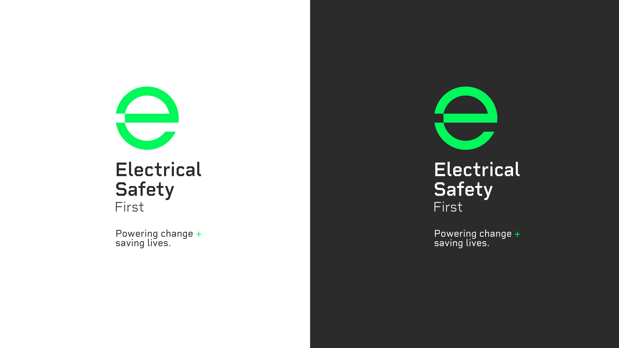

This activity was produced by Schoolzone on behalf of Electrical Safety First, the UK's leading charity working to keep families safe when using electricity at home.

Visit our *Switched On Kids website*for more.



