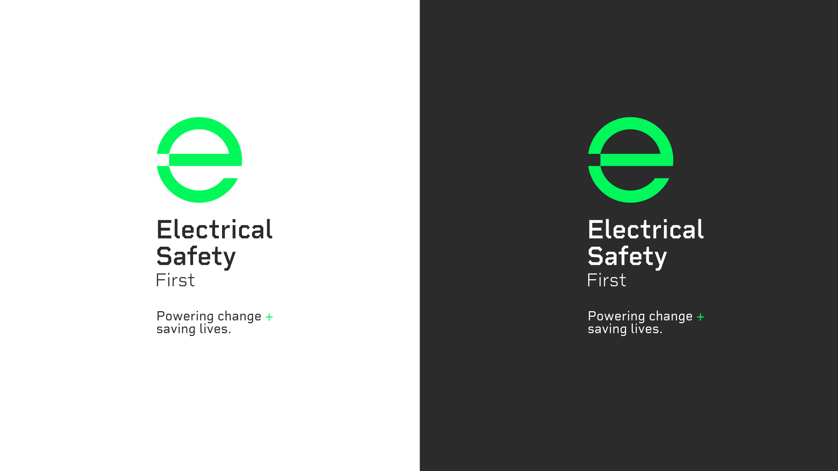



**LESSON PLAN - KEEPING OUR PETS SAFE**

**AROUND ELECTRICITY.**

**Shared writing activity on electrical safety around pets:**

**Objective:**

Pupils will collaboratively write a set of instructions for keeping pets

safe from electrical hazards.

**Introduction (10 mins):**

Discuss why pets can be at risk around electrical items.

1

.

Show pictures/examples of potential hazards (chewed cables, devices

near water).

2

.

**Main Activity (20 mins):**

**Brainstorming:**

Ask pupils open-ended questions:

What dangers do electrical items pose to pets?

How can we keep our pets safe?

**C**

**reate a list of safety tips together:**

Keeping devices out of pets’ reach.

Ensuring cables are tucked away.

Turning off and unplugging devices when not in use.

Avoiding leaving heaters on, especially unattended.

Keeping electrical items away from water sources like fish tanks.

**Shared Writing (20 mins):**

Divide pupils into small groups.

1

.

Each group writes a paragraph or step of the instructions.

2

.

Combine the paragraphs into a final set of instructions.

3

.

**Conclusion (10 mins):**

Share the final set of instructions with the class.

1

.

Discuss how these tips can be applied at home.

2

.

Encourage pupils to take the instructions home and share with

~~t~~

heir

families

**.**

3

.

