**DON’T BE ELECTRICKED!**

**You are an electrical safety inspector.**

**Consider safety requirements and potential dangers.**

**Check the electrical items for sale and sort them into safe/unsafe.**

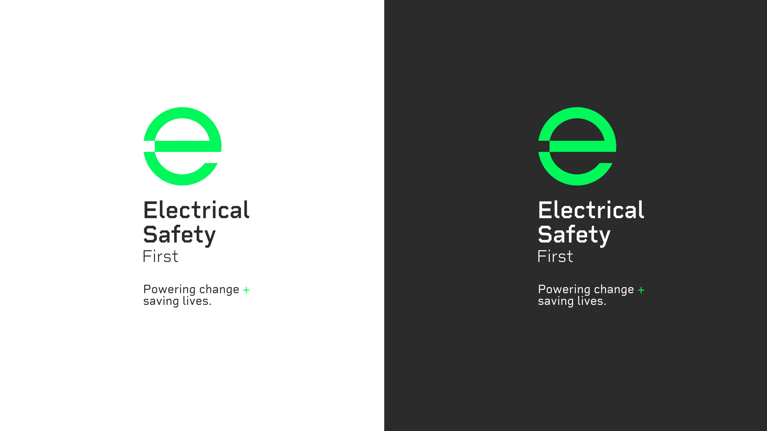

|  |  |
| --- | --- |
|  | Vinted Transforms User Research into Actionable Insights ... |
| The TikTok Logo: History and Why It Works (2023) - Shopify UK  E bike for sale!  Has been modified for increased speed!  Instructions not included.  Please message if interested! | Argos brand resources: accessing high-guality vector logo ... |
| Currys - the company has acquired a new style | From A to Z: The History of the Amazon Logo |  |
| Damaged charger cable — Stock Editorial Photo © norgallery #143215627More Than a 'Like': The Story of the Facebook Logo | Looka  Hi I have a charger for sale! Bargain price! Message me to buy now! | A computer screen shot of a box  Description automatically generatedAsda brand resources: accessing high-guality vector logo SVG ... |
| A red and black logo  Description automatically generatedA green circle with white text  Description automatically generatedLOGO_ASSETS | Asda brand resources: accessing high-guality vector logo SVG ... |

**DON’T BE ELECTRICKED!**

|  |  |
| --- | --- |
| Green Tick PNG, Vector, PSD, and Clipart With Transparent Background for  Free Download | Pngtree  SAFE | Green Tick PNG, Vector, PSD, and Clipart With Transparent Background for  Free Download | Pngtree  UNSAFE |
|  |  |

This activity was produced by Schoolzone on behalf of Electrical Safety First, the UK's leading charity working to keep families safe when using electricity at home.

Visit our *Switched On Kids website*for more.