**Additional Notes on Safety Resources**

**Design Your Own Electrical Safety Poster**

**KS1**

Activity summary:

Discuss the electrical safety poster and why the hazards exemplified would be a danger.

Design their own poster on electrical safety. Can be on any aspect or make it more specific e.g. household devices, fire hazards, plugs etc.

Learning objectives:

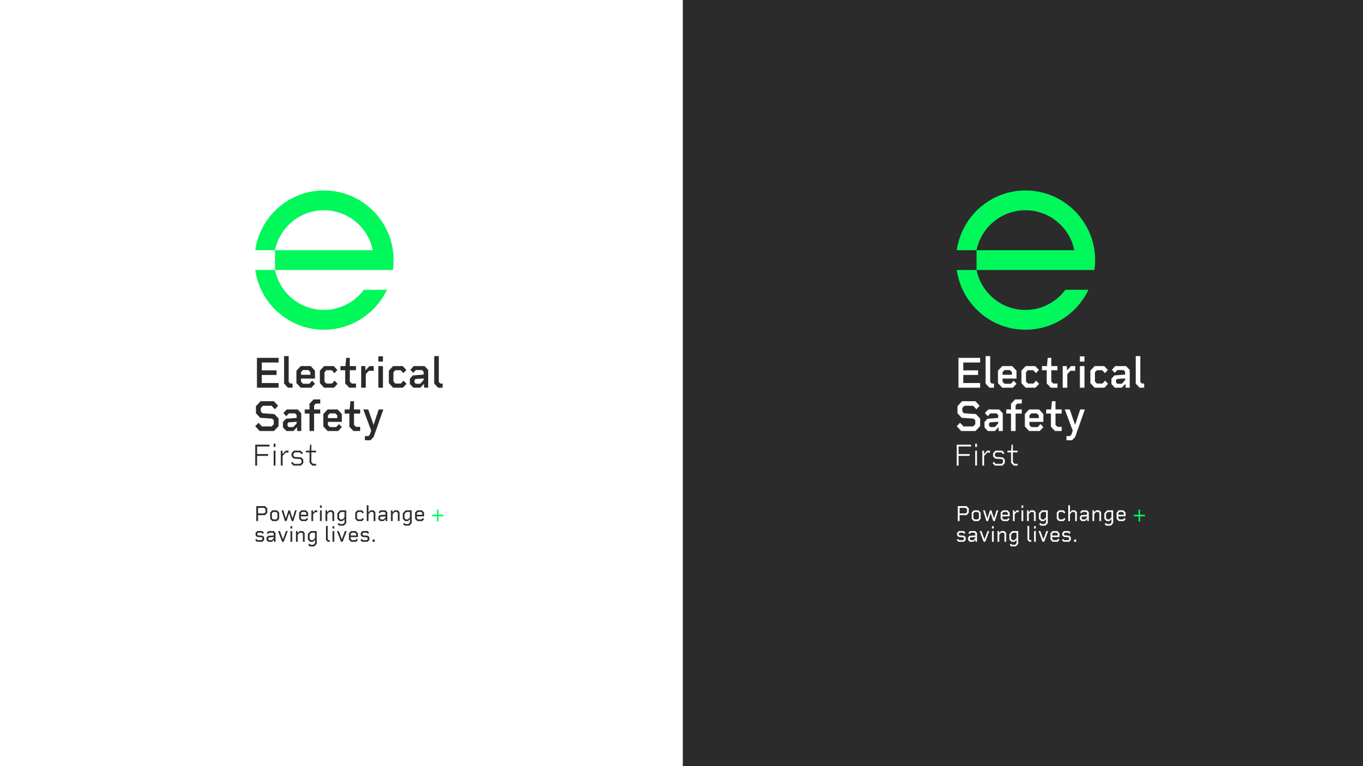To understand how using electricity in an unsafe way would pose a danger/hazard – what might happen if they do this e.g. getting water on a laptop might break it but could also start a fire.

To show they know how to use electricity safely.

Additional resources:

Poster template

