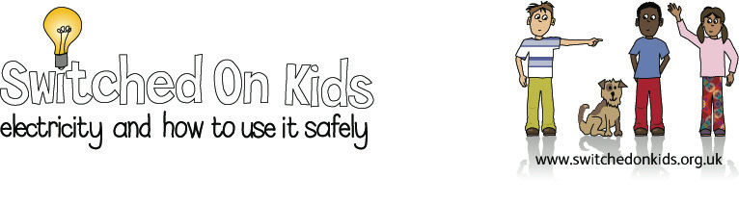
Lesson Plan 6 – Circuits and Conductors

Lesson Objectives:

- Children to become aware of the concept that some materials conduct electricity and others insulate.

- Children to experiment with different materials in a circuit.

Resource Materials Needed:

- Bulbs
- Batteries
- Wires
- Rubber
- Metal Key
- Coins
- Chalk
- Paper Ball

Classroom Activities:

- Ask the children if they can remember making a circuit and the components they needed to make the bulb light. (Previous lesson plan)

- Show the children the components and ask them what the components are made from.

- Look at the insulated piece of wire and ask children to suggest why the wire is made of metal and surrounded by plastic. Introduce the concept of materials which conduct electricity and those which insulate electricity.

- Look around the classroom at electrical devices. Children to record where they can find insulators on electrical devices i.e. plastic on switches, plugs and wires.

- Look again at the circuit and ask the children what the connections within the circuit are made from. Explain that metal is a good conductor of electricity.

- Give the children components to make a circuit and check that they can make the circuit work.

- Give the children a number of objects e.g. coin, rubber, ball of paper and key, to insert into the complete circuit to see whether it will still work.

- Children to record their results. Discuss results with children. Try to get the children to tell you that the objects which conducted electricity were made of metal.

- Children to write some sentences about their experiment, i.e. the objects made of metal let the electricity pass through. The objects made of plastic did not. Metal is a good conductor of electricity, plastic is not. The teacher could write these sentences as a gap fill on the board.

Interactive Whiteboard Activity:

Go to interactive whiteboard website address: https://www.bbc.co.uk/bitesize/articles/zxv482p

These activities ask pupils to identify items that either conduct or insulate electricity. Drag items, such as the key or rubber onto the circuit to identify those objects that pass electricity through them to get the light bulb to light up (conductors) or those which do not (insulators).

Expected Outcomes:

- Children can understand that some materials conduct electricity and others insulate.

- Children have investigated different materials in a circuit and recorded results.

- Children have made generalisations about materials which conduct electricity from their results.

National Curriculum:

England: Key Stage 2, Science, Sc3 1c, Sc4 1b

Wales: Key Stage 2, Materials and their properties 1.3,
physical processes 1.3

Scotland: 5-14 Guidelines, Science, Properties and uses of energy Level C, Level D

Northern Ireland: Key Stage 2, Physical processes, electricity

