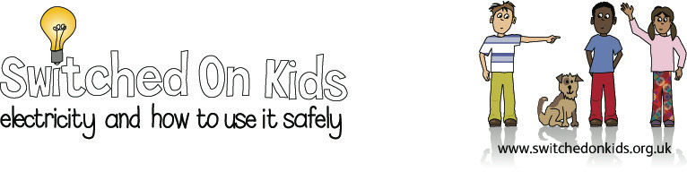
Lesson Plan 5 – Switches

Lesson Objective:

To make children aware that a switch can be used to make or break a circuit to turn things on or off (using either batteries or mains powered electricity).

Resource Materials Needed:

- Bulb and bulb holders
- Wires, batteries, sticky tape, paperclips, corks, drawing pins
- Screwdriver
- Handout on switches from Switched on Kids website.

Classroom Activities:

- Ask the children to think of some devices that use a switch.

- Ask them to suggest what a switch does and what would happen if appliances didn’t have switches.

- Demonstrate how to make a switch using a cork, drawing pins, a paperclip and 2 wires.

- Show the children the other components of the circuit and ask them to complete the circuit, incorporating the switch.

- Ask the children for their ideas about how the switch works and test their ideas.

- Demonstrate how the switch works and ask the children if they can explain how the switch breaks and completes the circuit.

- Ask the children about the materials that the switch is made from (metal) and the importance of this in conducting electricity.

- Give the children materials to make a switch and circuit, as well as the handout from Switched on Kids website for them to refer to.

- Children to demonstrate their switches working and describe any difficulties they had in making them and how they overcame them.

Additional/Extension Activity:

Children could make a lighthouse for their working circuit, using a cardboard tube and paint.

Expected Outcomes:

- Children should be able to construct a switch which turns a bulb on and off.

- Children should be able to explain how their switches work.

National Curriculum:

England: Key Stage 1, Science, Sc4, 1c, Key Stage 2, Sc4, 1a

Wales: Key Stage 2, materials and their properties 1.3, physical processes 1.2

Scotland: 5-14 Guidelines, Science, properties and uses of energy Level C

Northern Ireland: Key Stage 2, Physical processes, electricity

