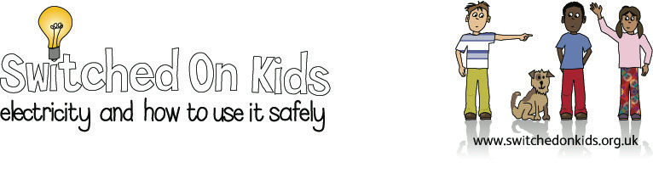

Lesson Plan 4 – Changing Circuits

Lesson Objectives:

- Children learn how to change the brightness of bulbs in a circuit.

- Children will make predictions about changes to the circuit and check these predictions.

- Children will present their results in writing and drawing.

Resource Materials Needed:

- Bulbs
- Batteries
- Wires

Classroom Activities:

- Show the children a working circuit. Explain that you are going to change different parts of the circuit to see what will happen.

- Ask the children to predict what will happen if another battery is added.

- Children add a battery and check their prediction.

- Ask the children to predict what will happen if a further battery is added. If possible, demonstrate. If not, explain to the children that too much power in the circuit will cause the bulb to burn out.

- Ask the children to predict what will happen if another bulb is added to the circuit. Children add the bulb to check their prediction.

- Give the children the opportunity to change the number of bulbs and batteries in the circuit. Ask them to tell you their results.

- Give the children some predictions to check, right or wrong:

  - With 2 batteries the bulb glowed dimly.
  - With 2 batteries the bulb glowed brightly.
  - With 1 battery and 2 bulbs the bulbs glowed dimly.
  - With 1 battery and 2 bulbs the bulbs glowed brightly.
- Children to draw some of the circuits, colouring the bulbs to show their intensity.

Additional/Extension Activities:

Write on the board the words “dimly”, “normally”, “brightly”, “off”.

Write the beginnings of sentences, describing the results of the experiment that children have to complete using the words.

E.G. With 1 battery the bulb glowed ……
With 2 batteries the bulb glowed more …….. than with one battery.

Expected Outcomes:

- Children should be able to predict and check how changing the number of batteries or bulbs in a circuit affects the brightness of the bulb.

- Children should be able to describe what is likely to happen if too many batteries are added to the circuit.

- Children should be able to describe the results of their experiment in drawings and sentences.

National Curriculum:

England: Key Stage 2, Science, Sc3 1c, Sc4 1b

Wales: Key Stage 2, materials and their properties 13, physical processes 1.3

Scotland: 5-14 Guidelines, Science, properties and uses of energy Level C, Level D

Northern Ireland: Key Stage 2, physical processes, electricity

