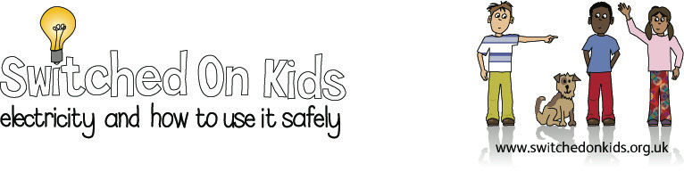
Lesson Plan 3 – Batteries and Circuits

Lesson Objective:

To raise children’s awareness that batteries supply electricity and that they can be handled safely.

Resource Materials Needed:

- Children to bring in a battery operated toy, torch or bike light

- Drawing paper and pencils

Classroom Activities:

1. Children to show each other their toys and explain what the toy can do when it has batteries included and what happens when it doesn’t have them in.

2. Select a small number of toys which use different types of batteries. Help children take the batteries out of the toys and look at their different shapes and sizes i.e. rectangular/cylindrical/large/small.

3. Discuss with the children why some toys use more batteries than others or use a different size of battery.

4. Put the toys into groups according to the types of batteries they use.

5. Record results graphically, children could pictorially represent the toys and shape of battery i.e. using a tally chart or bar graph.

6. Ask the children to find + and – signs on batteries and ask them what they think they mean. Ask the children where they have seen these signs before.

7. Help the children to put the batteries into the toys. Put the batteries in the wrong way and ask the children to predict what will happen.

8. Children to practise putting the batteries in and taking them out.

Additional/Extension Activities:

- Children to draw some of the toys and their batteries.
Interactive Whiteboard Activities:

Go to section Using Electricity at website address: https://www.bbc.co.uk/bitesize/articles/zkjnvj6#znvwxg8

This activity helps show what happens to a light bulb when a battery is inserted into the connection.

Expected Outcomes:

- The children should be aware that batteries supply electricity

- That items which use batteries can be handled safely.

- The children should be able to make connections in circuits to the positive and negative poles of the battery.

National Curriculum:

England: Key stage 1, Sc4 1b, simple series circuits involving batteries, wires, bulbs and other components.

Wales: Key Stages 1 & 2, to construct and explore simple circuits.

Scotland: 5.12 knowledge & understanding; energy and forces; simple electrical circuits.

Northern Ireland: Key Stage 2, movement and energy: possible key questions - how do things work.

