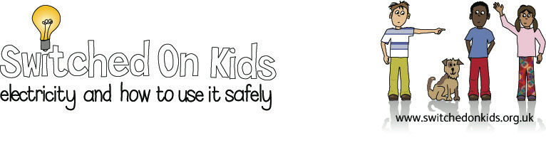

Lesson Plan 2: Electrical Safety

Lesson Objective:

To raise children’s awareness to recognize that there are hazards in physical processes, assess risk and take action to reduce risk to themselves and others.

Resource Materials Needed:

- Colouring sheet from Switched on Kids website

- A3 coloured sugar paper

- Old newspapers

- Scissors, glue and felt tip pens

Classroom Activities:

- Ask the children why electricity can be dangerous and what we can do to be safe around it.

- Look at Switched on Kids colouring sheet and help the children to find the electrical hazards in the picture.

- Discuss electrical appliances that are used in the rooms of our homes and what we have to do to be careful around them.

- Help the children make a list of Do’s and Don’ts around electricity, e.g.

  - Do:
    - Ask an adult for help to change a light bulb
    - Turn off electrical appliances when not in use

  - Don’t:
    - Put drinks or any liquid on or above electrical equipment
    - Touch electrical appliances with wet hands

- Look at the safety poster on website address at: www.switchedonkids.org.uk or print out. Help children to read the electrical safety tips and see how many of the points the children came up with that are on the poster.

Additional/Extension Activities:

Help the children make their own poster on electrical safety, referring to their list of do’s and don’ts, using the felt pens and sugar paper. They could cut out the letters of the title of the poster ‘Electrical Safety’ from newspaper headlines and cut out any pictures of electrical appliances they may find.

Interactive Whiteboard Acitivities:

Go to Switched on Kids website at www.switchedonkids.org.uk and click onto the Electrical Safety in Your House.

Room by room, the children should try to identify the possible electrical hazards in each room. Help the children check their predictions by having them click on the different appliances to see what happens.

Expected Outcomes:

Children should have an awareness of the dangers of electricity

Children should have used their ability to predict risk.

Children should have learnt the importance of using electricity safely and with care.

National Curriculum:

England: Key Stages 1 & 2, physical processes; breadth of study; health
and safety.

Wales: Key Stage 1, physical processes; that everyday appliances use electricity and that they should be used with care.

Scotland: Energy and forces; taking responsibility for their own and others health and safety.

Northern Ireland: Key Stage 1 Science; the use of electricity as an energy source and the importance of using it safely.

