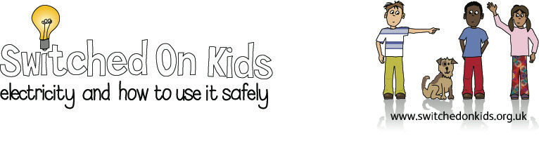

Lesson Plan 1: Everyday Appliances That Use Electricity

Lesson Objective:

To raise children’s awareness of everyday appliances which use electricity; these include things that light up, heat up, produce sounds and move.

Resource Materials Needed:

- Unwanted catalogues / magazines / promotional material from electrical shops to cut images of everyday objects and electrical appliances

- Scissors and glue

- A simple diagram of a house on A3 paper

- Interactive whiteboard (optional)

Classroom Activities

- Look around the classroom and find objects that use electricity and
those which do not.

- Show the children cut out pictures and ask them to separate into electrical and non-electrical objects.

- Look through catalogues with the children and ask them to pick out some objects which use electricity.

- Children to cut out some pictures.

- Discuss with the children where these objects would generally be found in around the home and encourage the children to talk about where those objects are in their own homes, recognising the children’s individual differences.

- Show the children the simple diagram of a house and ask them to place their cut out pictures in the different rooms.

- Give the children glue to make a poster with their pictures and the house.

Additional/Extension Activities:

Put the appliances into categories according to what they do i.e.

Making Heat Making Sound Making Light Moving
Kettle C.D. player T.V. T.V.
Cooker T.V. Lamp Washing Machine

Talk about appliances that fit into more than one category or don’t fit at all.
The children might think of another category.

Interactive Whiteboard Activities:

Go to section about electricity at website address:
https://www.bbc.co.uk/bitesize/topics/zj44jxs/

These activities ask pupils to identify items that use electricity, drag items into the room in a house where they might be used and identify objects that need either mains electricity or battery power to work.

Expected Outcomes:

- The children should be able to record the appliances in categories and to be able to explain their reasons for doing so.

- The children should be able to identify appliances which use electricity and those which do not.

Additional Resources:

- www.switchedonkids.org.uk
- A simple diagram of a house printable on A3 paper (pdf)
- Switchedonkids Colouring Sheet (pdf)

National Curriculum:

England: Key Stage 1 Science Sc4, 1a

Wales: Key stage 1 Science: electricity

Scotland: Science 5.12, knowledge and understanding: energy and forces: safe everyday uses of energy.

Northern Ireland: Key stage 1 Science: the use of electricity as an energy source and the importance of using it safely.

